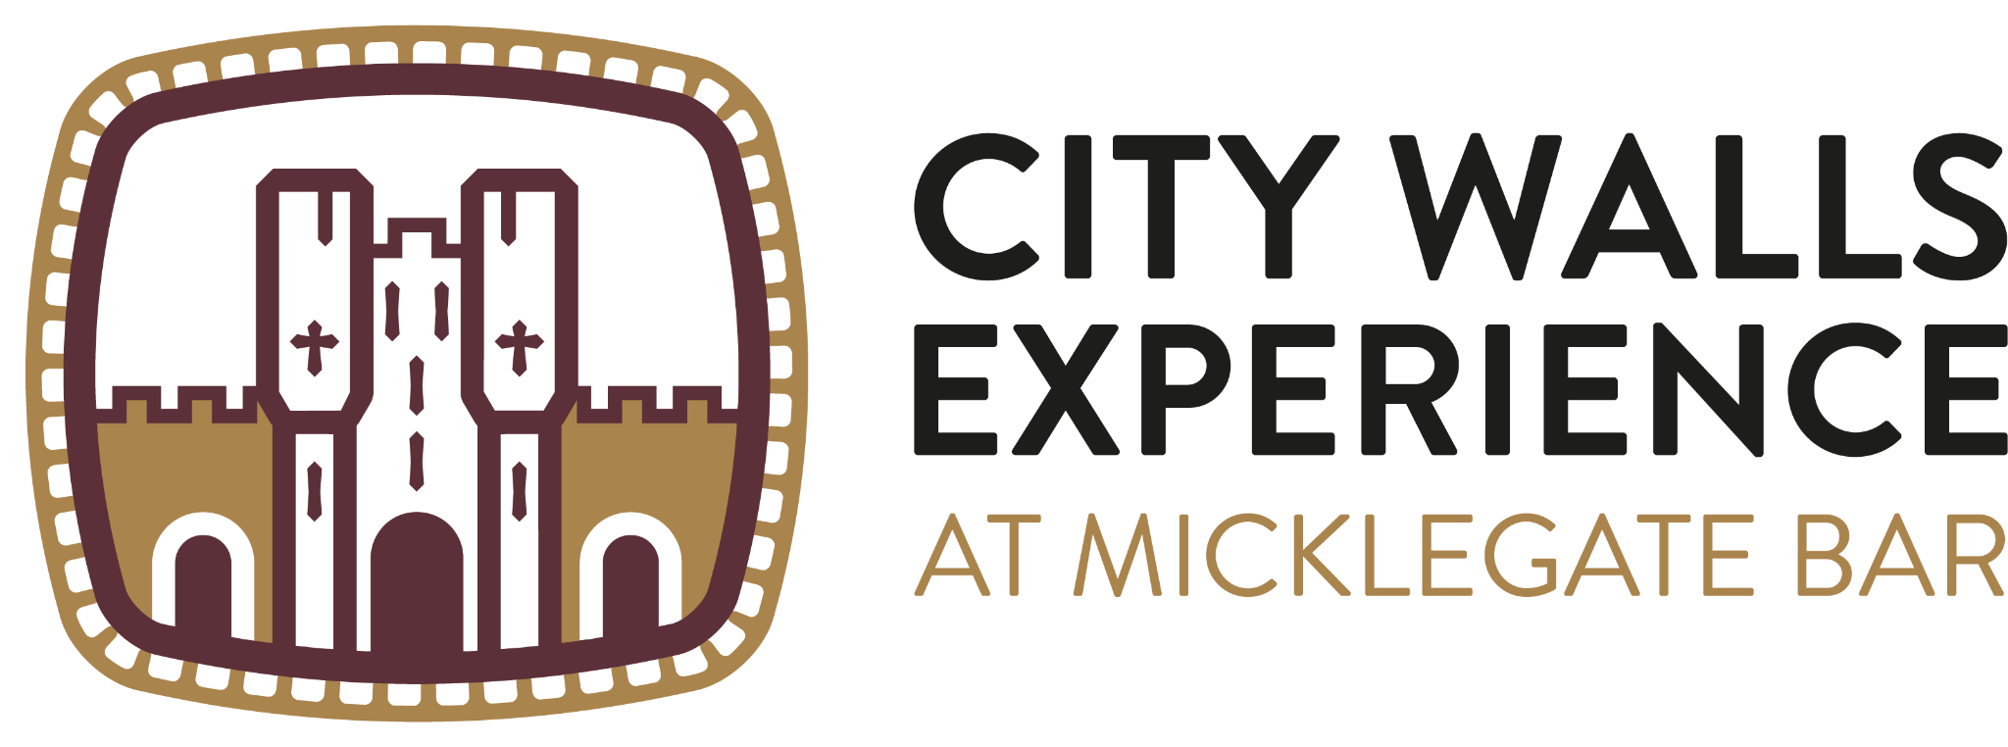

Accessibility Guide for
City Walls Experience at Micklegate Bar
groups@yorkat.co.uk, 01904 615505, https://yorkcitywalls.com/
Contact for accessibility enquiries: access@yorkat.co.uk

Welcome
Housed in the gatehouse of Micklegate Bar, visit the City Walls Experience to discover how York came to be a walled city and how the walls have evolved and changed since the first embankments were built by the Romans.
The City Walls Experience has been designed to be as inclusive as possible within the confines of Micklegate Bar, and we warmly welcome all disabled visitors.
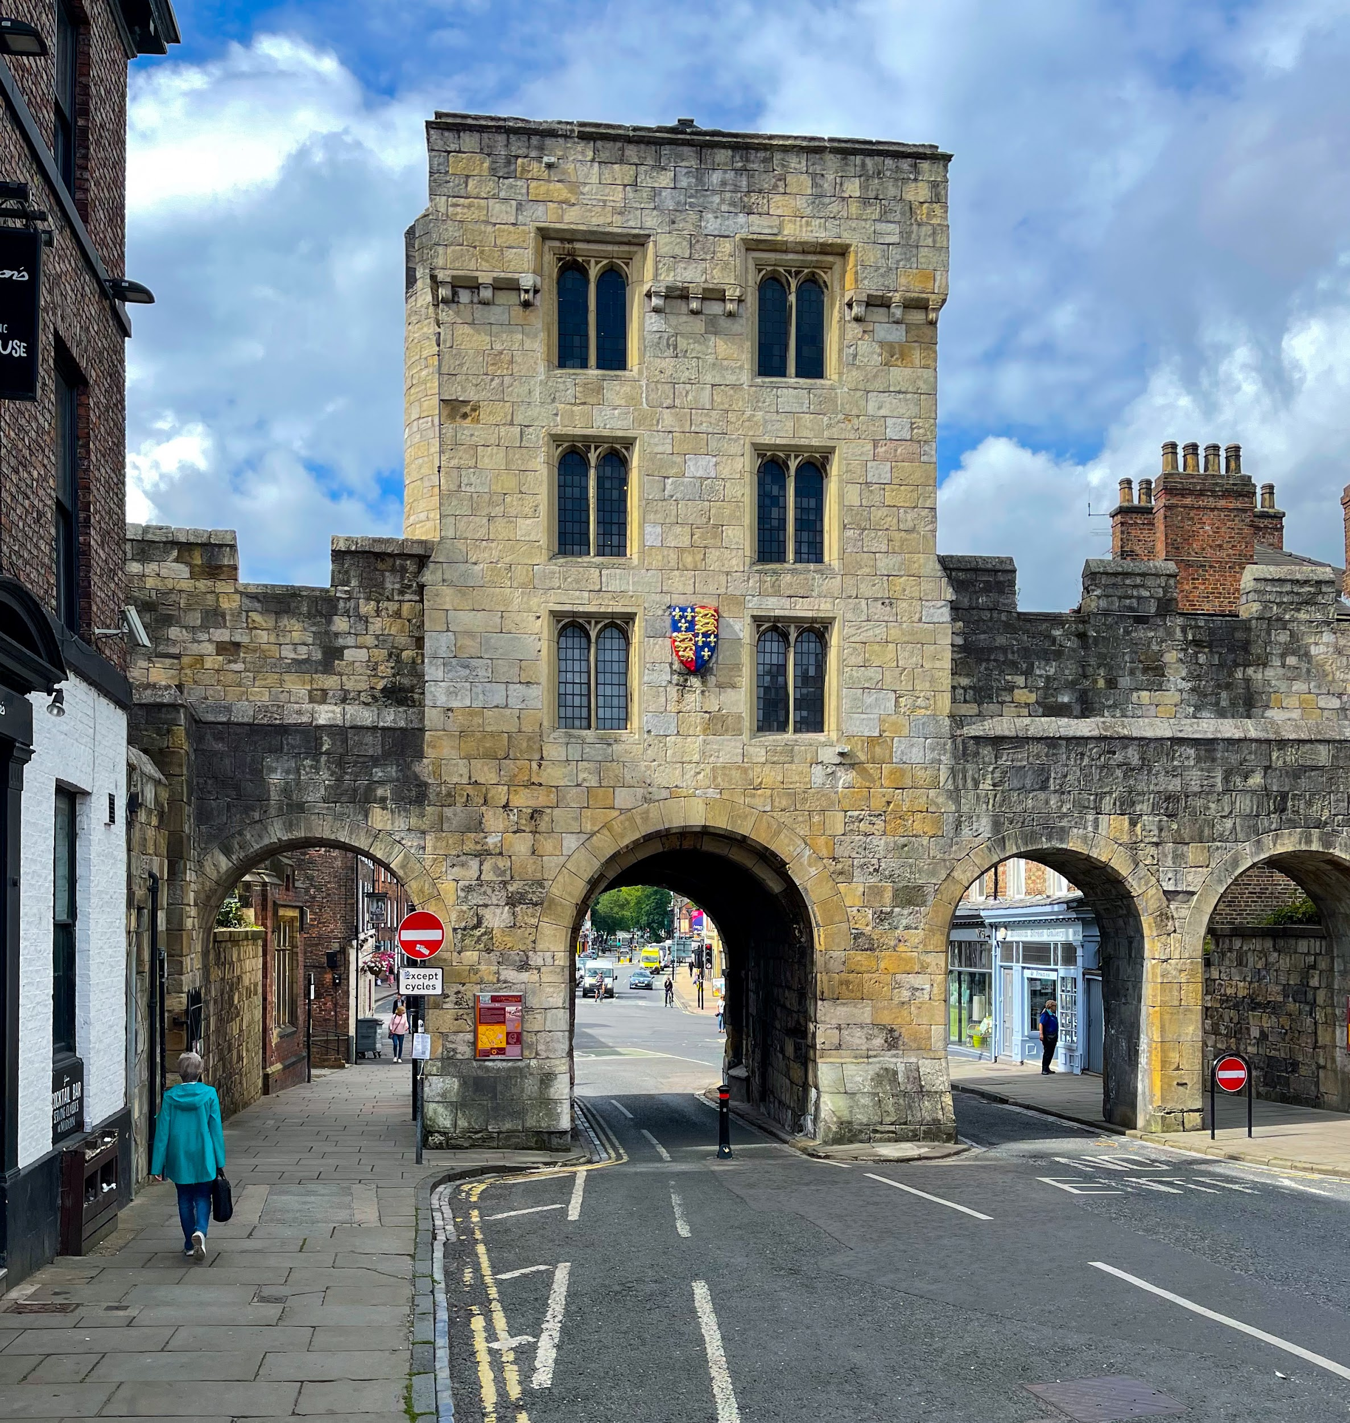

At a Glance
Due to the historic nature of the building, the City Walls Experience can only be accessed via stairs (25 steps with a handrail). Likewise, the upper floors can only be accessed via stairs. There are no toilets and no lift.
All staff have disability awareness and Autism Awareness training whilst some staff have BSL training.
We have interpretation available in level 2 Braille translation and in large print. Visual stories are available to download on our website and we have paper copies at our front desk.
We have a complimentary ticket policy for carers and personal assistants, and all tickets are valid for one year, allowing as many returns and re-entries as you like. Seating is available throughout the building, and we have sensory packs for you to use at our front desk.
Sensory Information:iIn general, the City Walls Experience is fairly quiet. There is noise from the outside, as we are near a fairly busy intersection. The sounds of lorries, buses, and motorcycles, along with sirens and horns honking, are common although not constant. Our quietest time is generally during the week, particularly during term time.
Please note that we are only open from mid-February (February half-term) to the end of October.

Getting here
Micklegate
City Centre
York
YO1 6JX
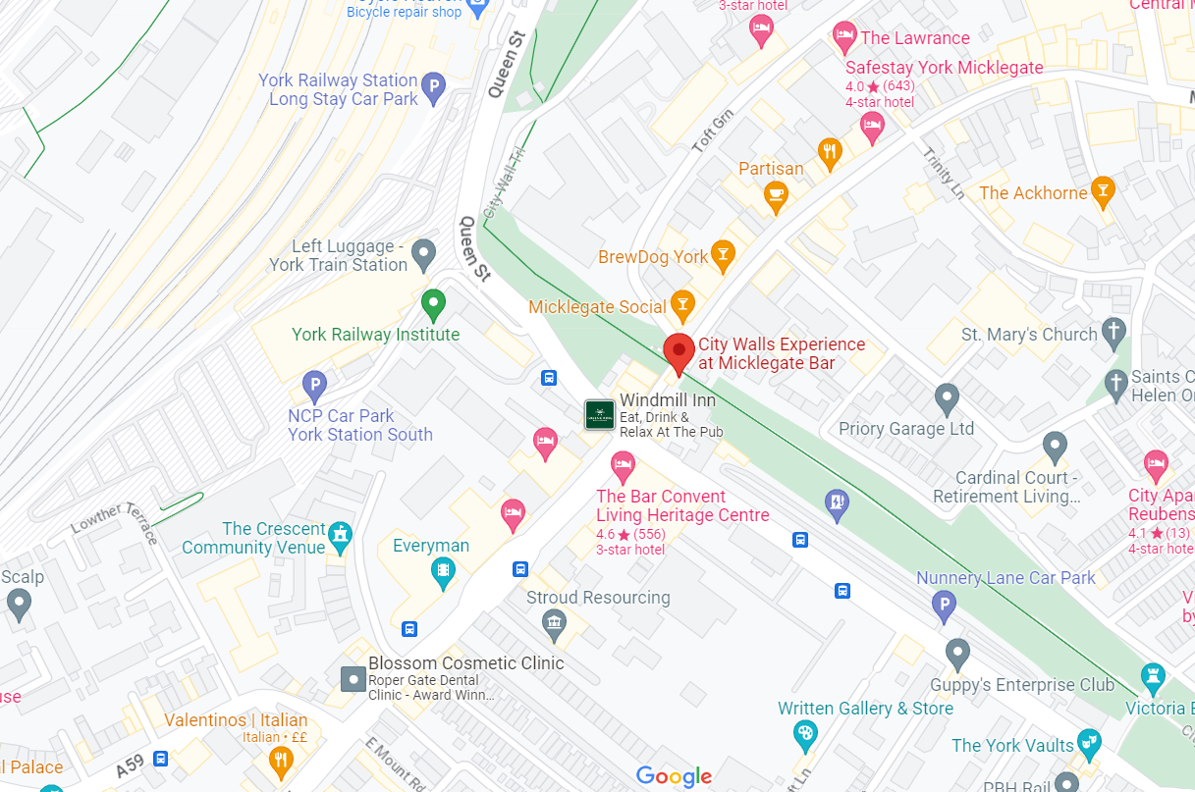
https://goo.gl/maps/Rt5FseDpVqzPFoC76

Travel by public transport
You can get to the City Walls Experience at Micklegate Bar by bus and train.

Bus
The nearest bus stop is just outside the city walls along Nunnery Lane. First Group York and Transdev both service this stop. The bus stop is 0.1 miles / 0.2 km from City Walls Experience at Micklegate Bar.

Train
The nearest train station is York Train Station. The train station is 0.2 miles / 0.3 km from City Walls Experience at Micklegate Bar.
York is on the East Coast main line between London and Scotland. It takes less than two hours to get to York from London. Trains run every half an hour, with at least 25 direct trains each week day. Direct rail services also run to York from many of the UK's main regional centres. York can be reached easily from all the following centres: Edinburgh, Glasgow, Birmingham, Bristol, Leeds, Manchester, Newcastle, Nottingham, and Liverpool. There are direct trains to and from Manchester International Airport that run every hour during the day.

Travel by taxi
The nearest drop off point is at the base of Micklegate Bar.
You can get a taxi with Streamline by calling 01904 656565. The taxi company has a wheelchair accessible vehicle.

Parking
There is no on-site parking at the City Walls Experience. The nearest car park is Nunnery Lane car park, located about 0.2 mi from the City Walls Experience. This car park has 12 dedicated disabled parking bays.
For more information about the car park, please check the council's website: https://www.york.gov.uk/directory-record/424/nunnery-lane-car-park

Arrival
The City Walls Experience is located inside Micklegate Bar on the York City Walls. There are two ways to access our museum.

From the City Walls
As you walk along the City Walls and reach Micklegate, you’ll see a stone overhang that you will need to walk under. In this overhand, you’ll find our wooden entry door.
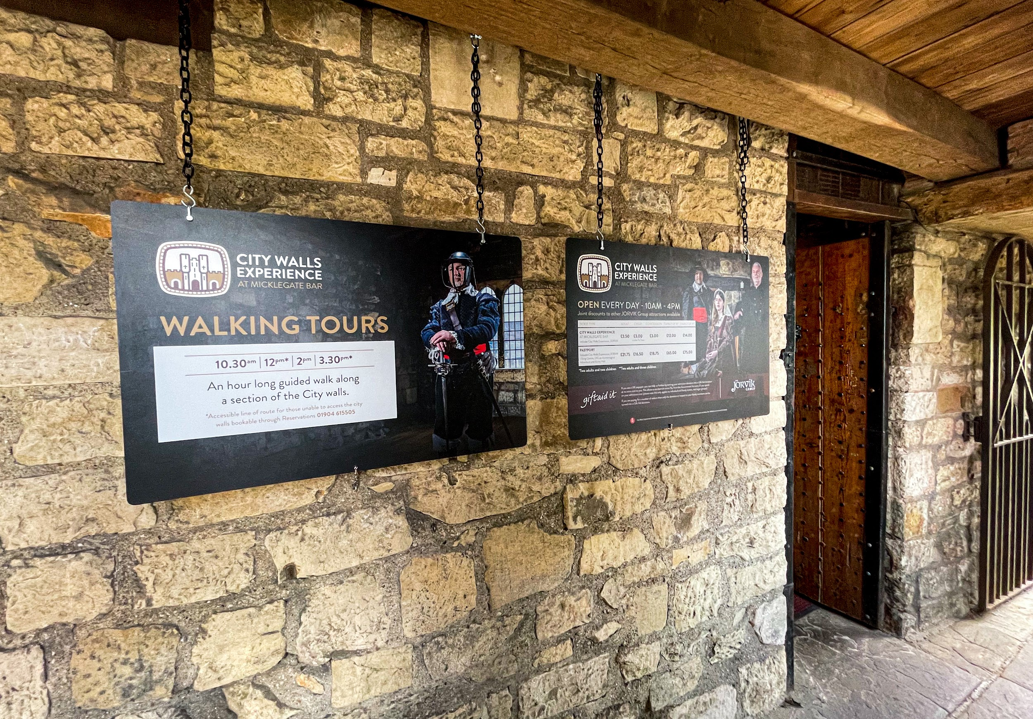
Please note that the City Walls are not wheelchair accessible and only service dogs are allowed.

From the street
There are two staircases on either side of Micklegate Bar that lead up to our museum. They are just inside the Walls.
One set is along the southeast side of the street. It has 24 steps, including a landing, that are 160mm high with a handrail along the left hand side. The staircase is 1090mm wide. Please note that the steps are stone and are slippy when wet.
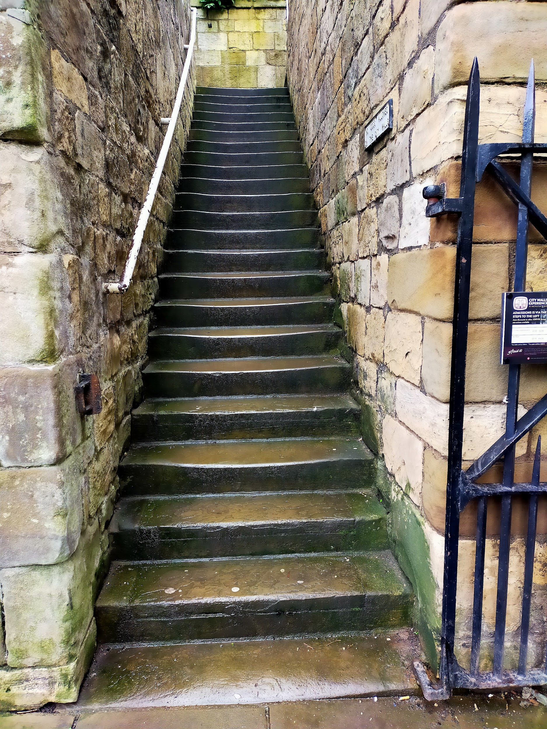
The other set of steps are on the northwest side of the street. It has 24 steps, including a landing, that are 160mm high with a handrail along the right hand side. The staircase is 1110mm wide. Please note that the steps are stone and are slippy when wet.
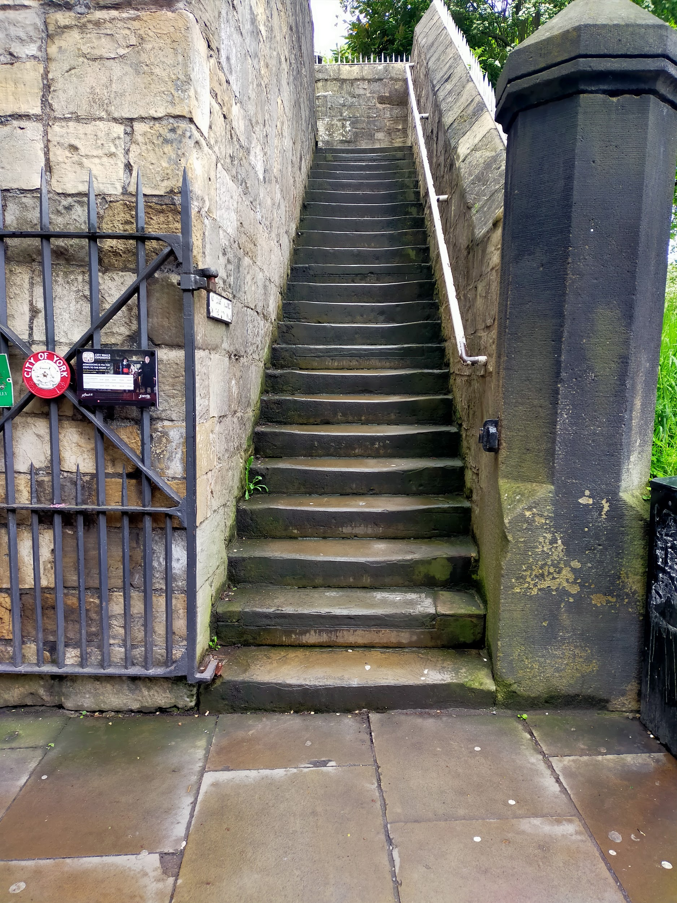
Our doorway is a manual medieval door, but it is left open during opening hours. The door is 700mm wide and swings inwards.
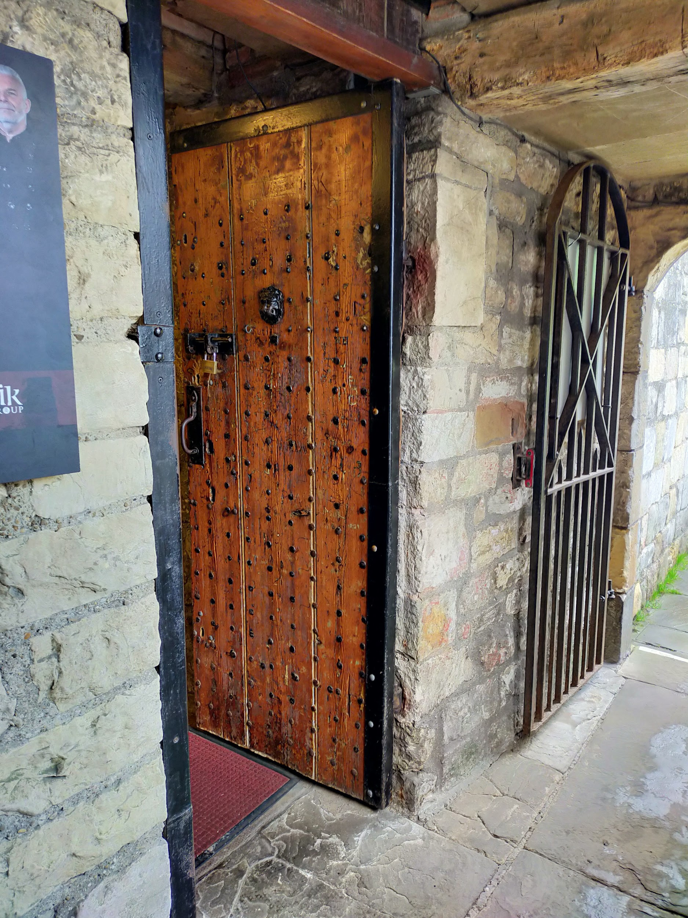
Due to the historic nature of the building, there are no ramps, no lifts, and a fair number of narrow stairs between floors. There are also no toilet facilities.
Max card holders are entitled to free admission (up to 4 people). Carers are also given free admission. Breastfeeding is welcome at all our attractions.

Inside the City Walls Experience
The City Walls Experience is located inside Micklegate Bar, which is part of the Grade I listed York City Walls. Because it’s a listed building, there’s lots of things we can’t alter. However, we’ve done what we can and we’re always happy to hear feedback on ways we can improve.
There are three floors to the City Walls Experience, with each floor housing one open room.

Main Floor: Front Desk & Retail Area
The first room you’ll enter is our admissions and retail area. If you’ve prebooked your ticket, the staff member on the desk will ask you for the last name of the booking and the reference number. If you have any discounts, such as a Max card, you may be asked to show proof of eligibility. This simply means showing your Max card, NHS staff card, or similar card. If you haven’t pre-booked, you’ll be able to buy your tickets here.
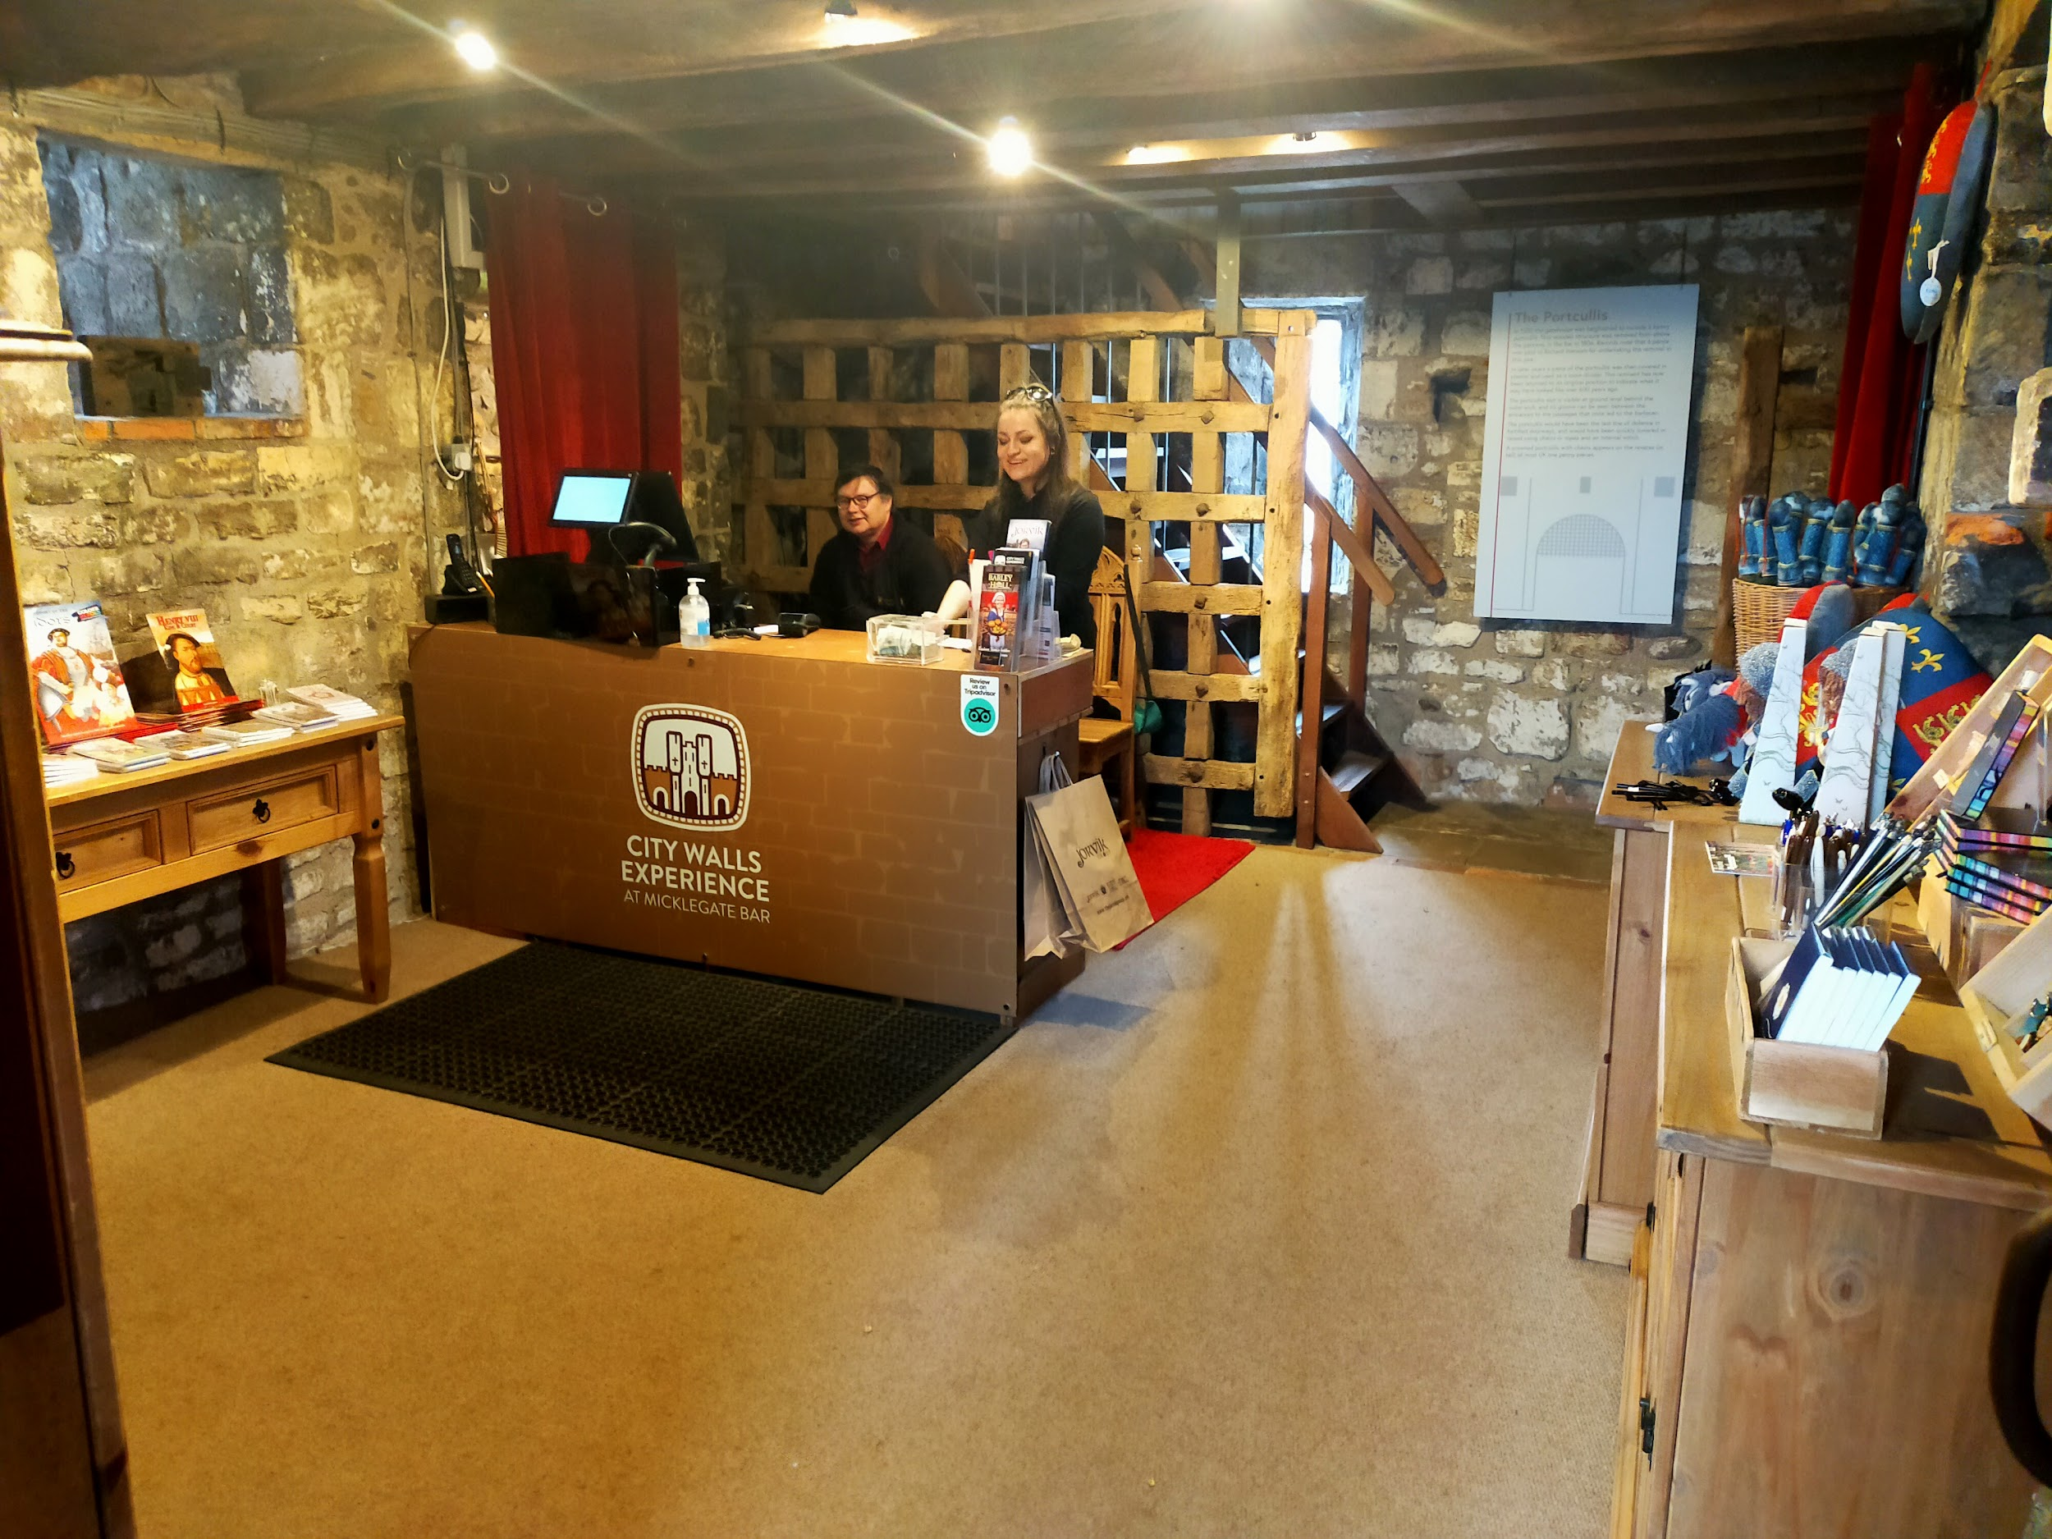
Our shop is also located here, where you can find a variety of books, souvenirs, and even replica medieval coins. Prices are clearly marked on small signs but also on stickers on each item. If you’re unsure about something, staff members are always at the desk and happy to help.
The desk is on the opposite side of the room from the door, but you will easily see it. This desk serves as both the admissions desk and the retail till. It’s 880mm high.
There is level access on this floor and the narrowest part of the area is 700mm wide. The floor is covered in a tightly woven carpet.
We offer complimentary tickets for carers and personal assistants, no proof required. Service animals are welcome and we have a water bowl at the front desk available for us.
We keep a number of access items at the front desk, including sensory bags, ear defenders, and physical copies of our access guides and visual stories.
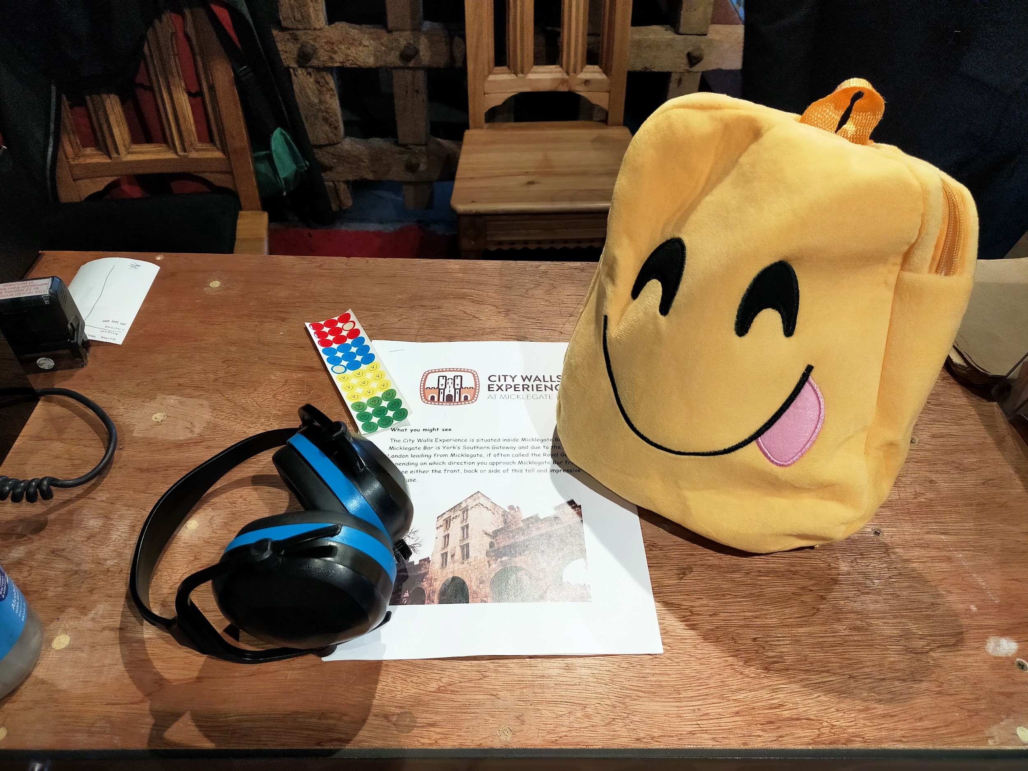
We operate a traffic light sticker system at all our attractions:
- Red sticker = please do not approach me
- Yellow sticker = please answer my questions but let me approach first
- Green sticker = please approach and speak to me
You can pick up the sticker colour of your choice at the front desk.

First Floor: Living within Micklegate
You can get to the first floor by climbing 12 steps that are 630mm wide with a handrail on both sides. These steps are steep (200mm high) and also have overhanging beams, so please mind your head!
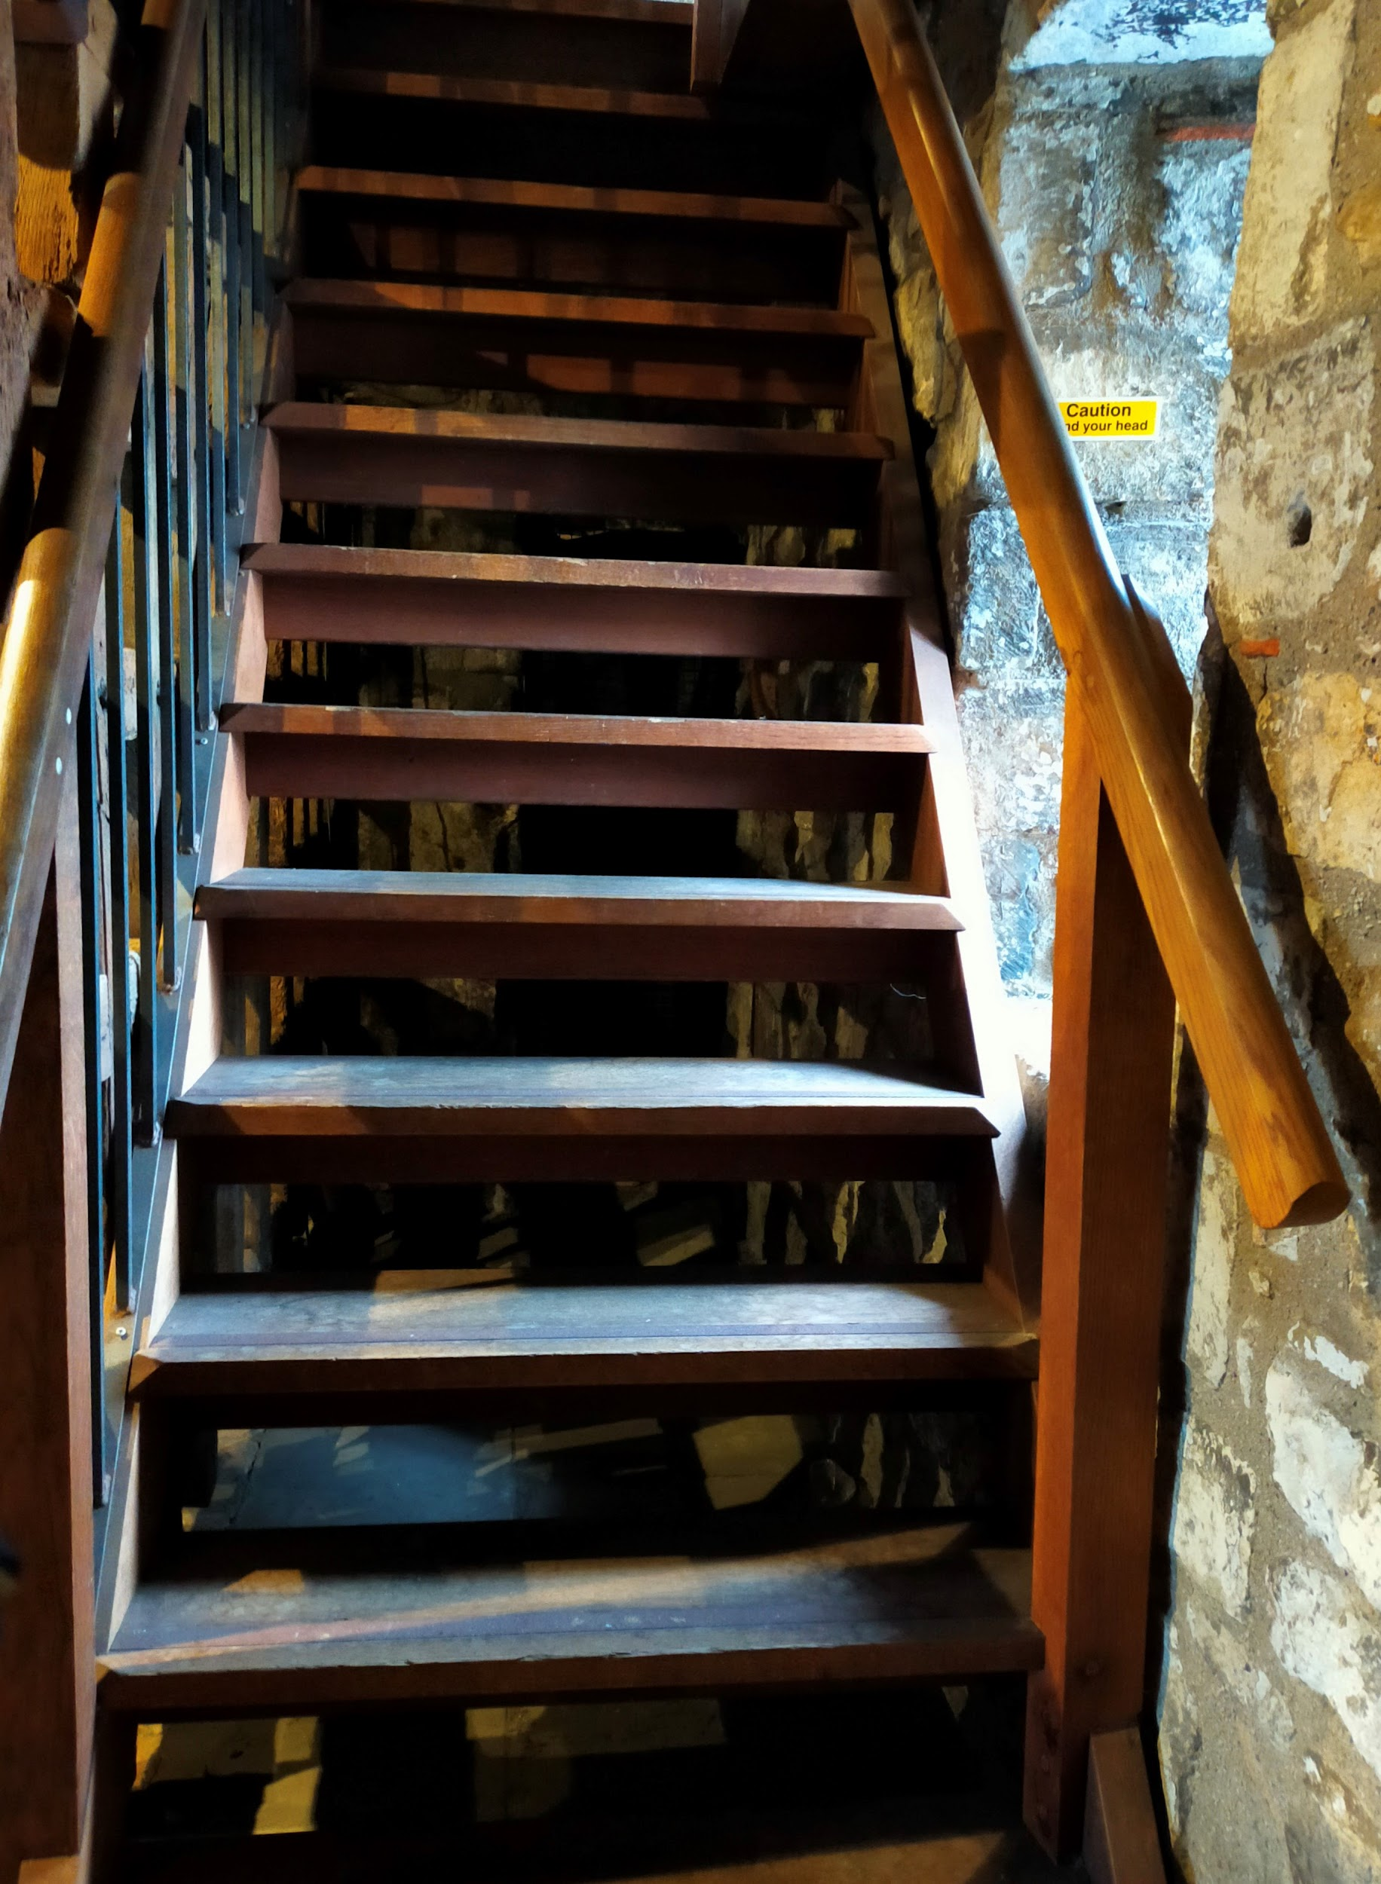
This area has a level wooden floor and the narrowest area is 760mm wide. Interpretation panels hang from the walls and should be readable from every level.
There are low cases with artefacts in them, as well as a tv screen featuring three videos. These videos present three different historical people who have lived in or visited Micklegate Bar: Princess Margaret Tudor, Sir Henry Slingsby, and PC Harry Sowden. Each video starts when you press a button along the right hand side of the fireplace surround, and all are open captioned (automatic subtitles). The videos are about two minutes long each, and we have a backless bench in front of the screen that is 450mm high.
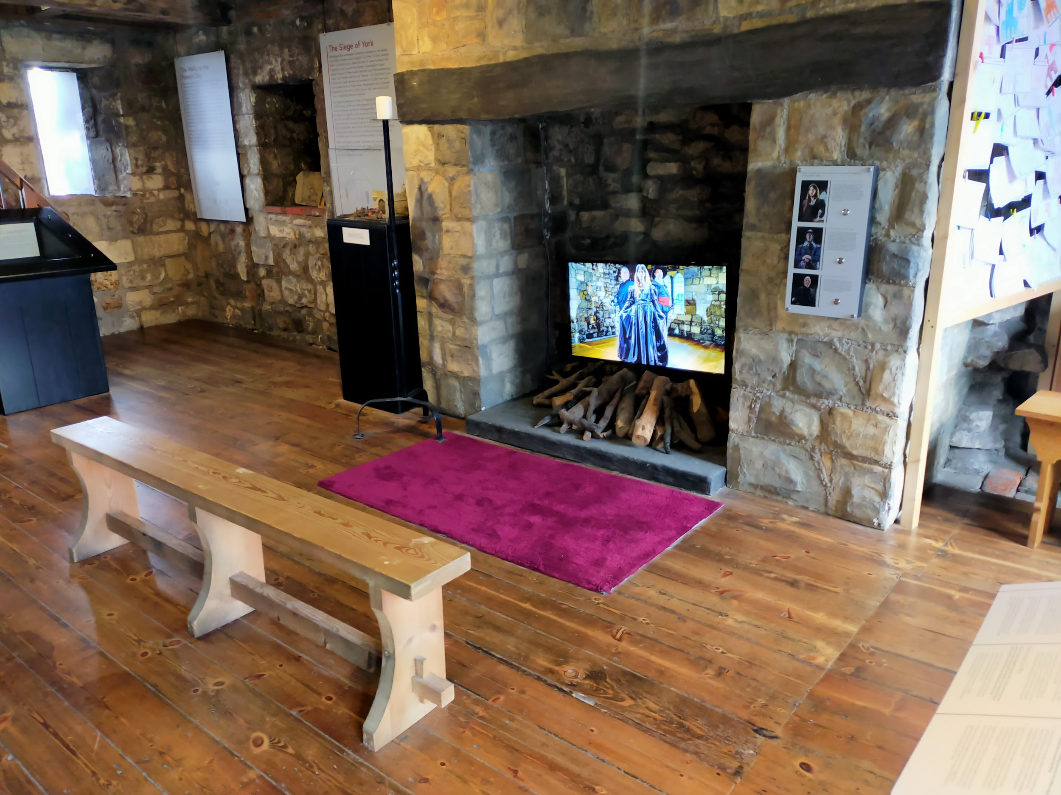
We also have a creative area here - we have postcard-sized cards with the outline of Micklegate Bar, and you’re invited to create your own heraldic shield to hang on the bar. We provide coloured pencils for you to draw and colour with, and you are welcome to take your final design with you or hang it on the wire frame that goes around the desk.
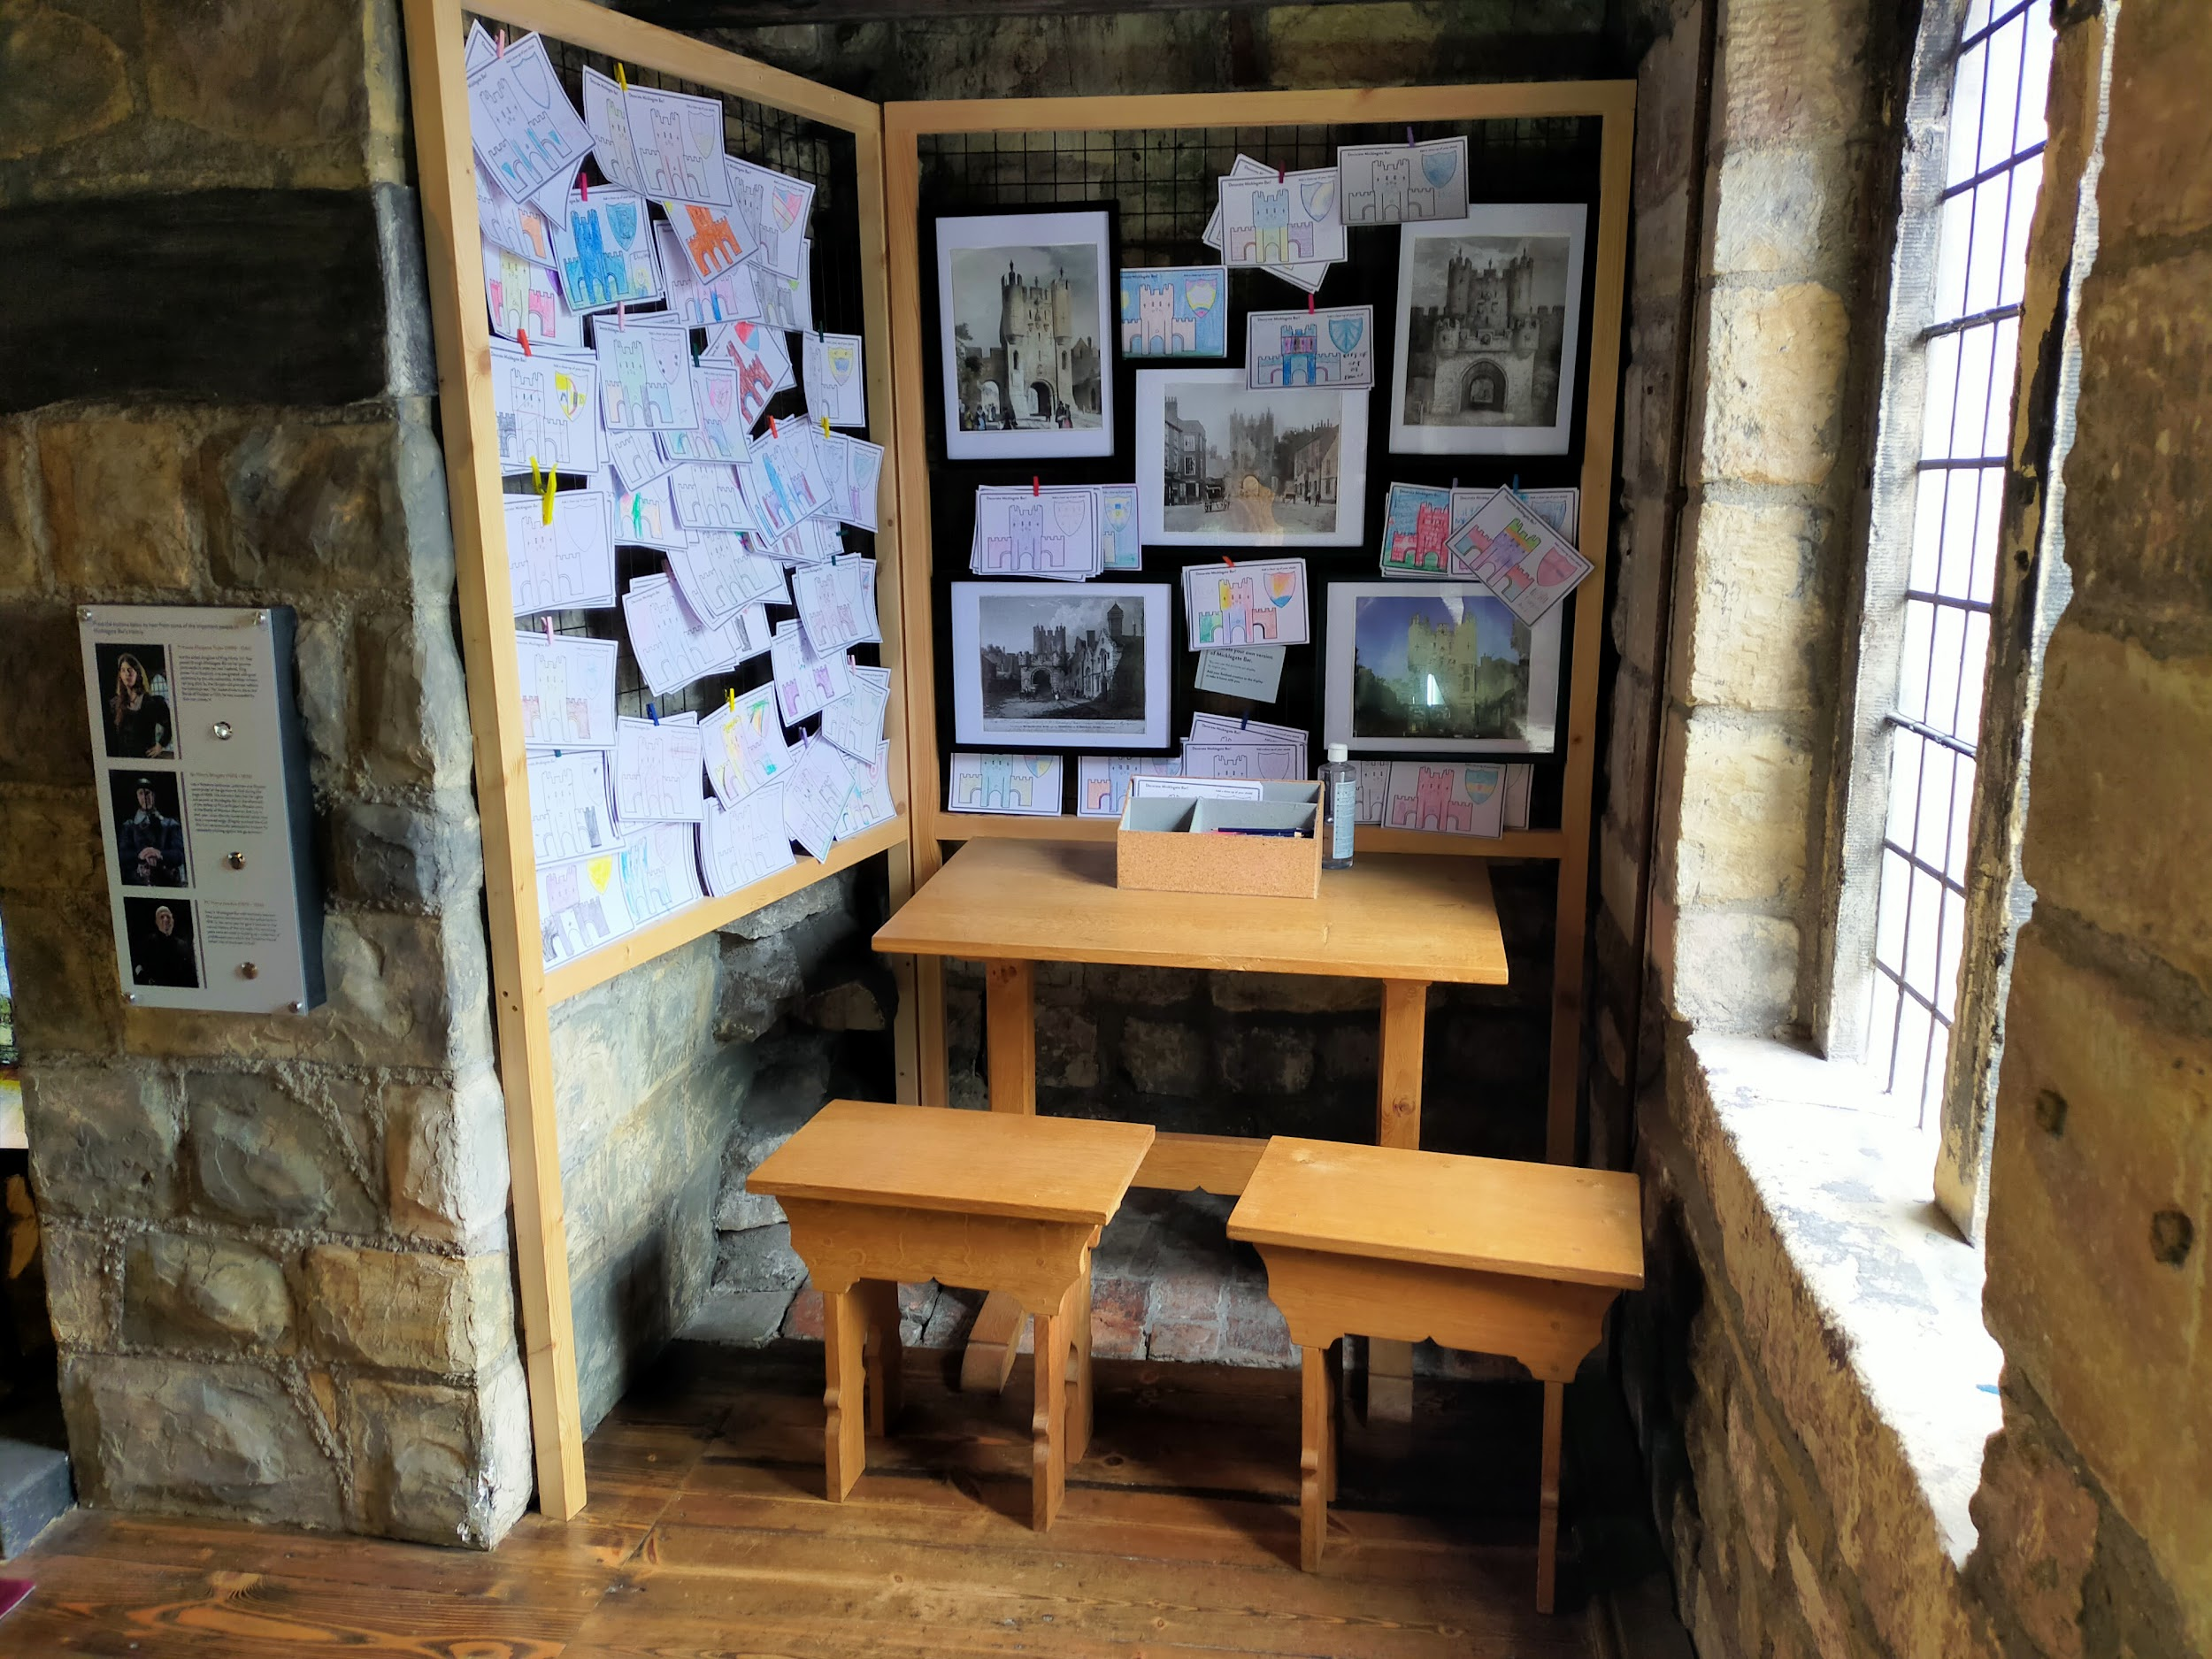
The table in this area is 740mm high and the two backless benches are 490mm high.

Second Floor: Walking the Walls
You can get here from the first floor by climbing a 13-step staircase that is 610mm wide at its narrowest point and has handrails on both sides. Again, these stairs are steep (190mm high) and please mind your head as there are overhanging beams.
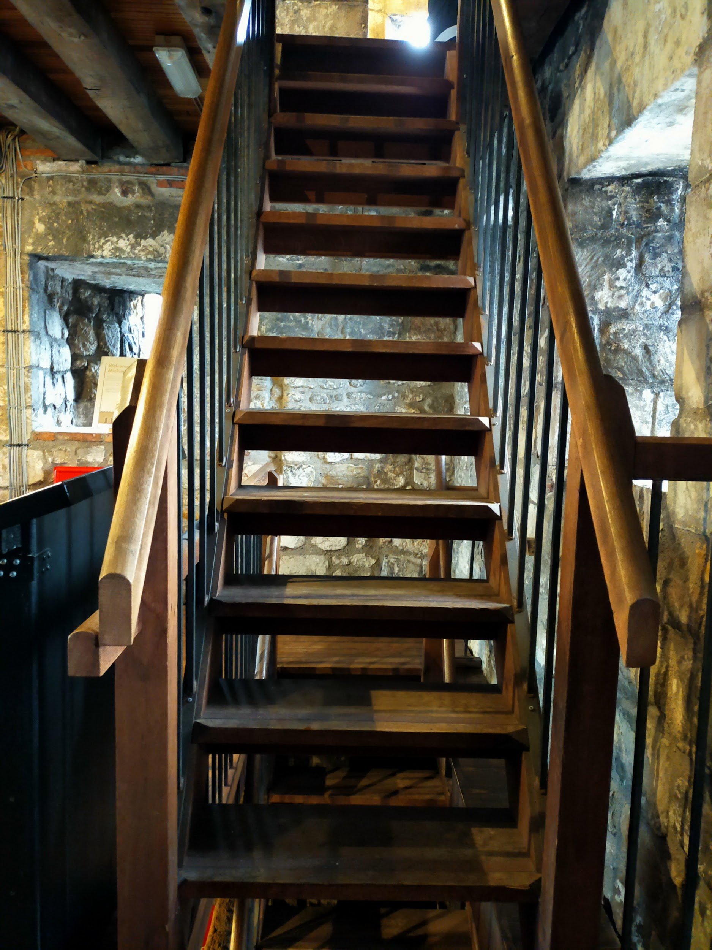
Our second floor gives you an overview of the City Walls and tells you about the history of the Walls and also each significant area as you walk the Walls. There is a map of the Walls in the middle of the room, and a silent video along the wall that shows a flyover of the entire length of the City Walls.
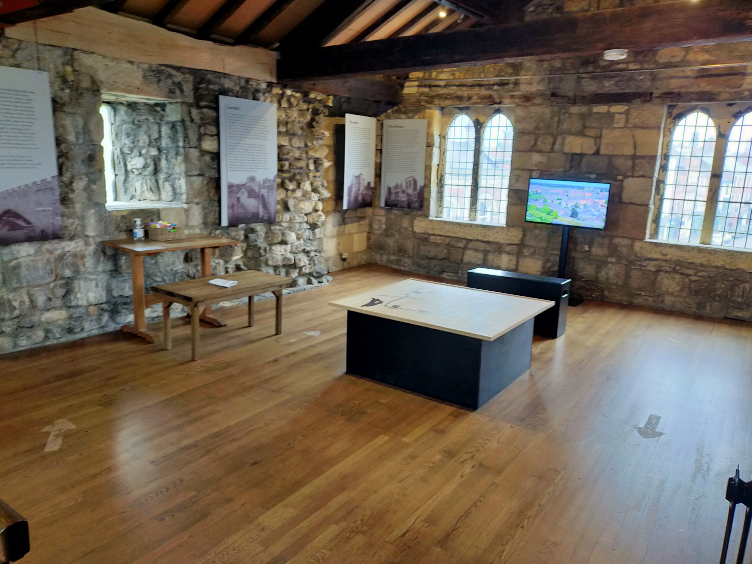
Interpretation panels hang from the walls and should be readable from every level. The backless wooden bench near the video is 500mm high.
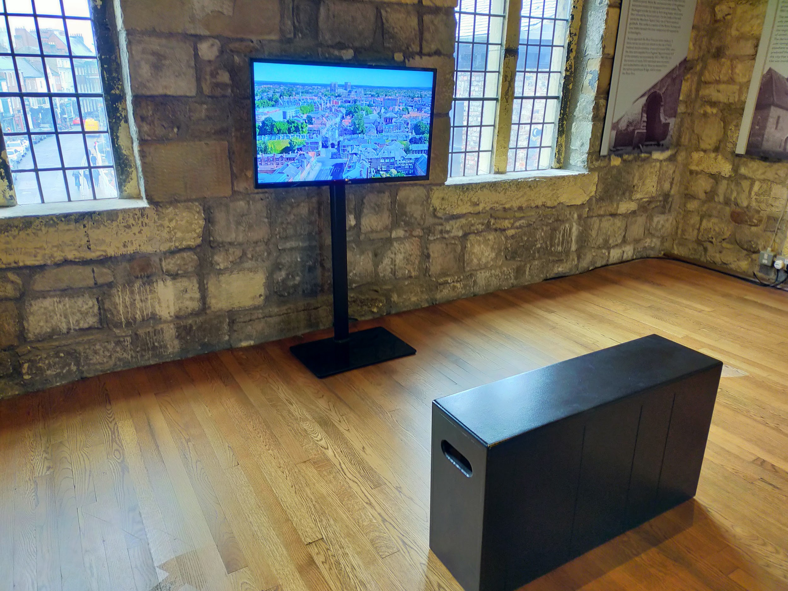

Walking Tours
We offer daily tours that go from our museum along the City Walls to Baille Hill. Our tour guides will tell you the history of the area and point out places of interest for you to explore later.
The tour lasts about 45 minutes and there is no seating along the way. The walking tour is also outdoors and open to the elements, but we can provide you umbrellas for the tour.
The tour goes along the City Walls and therefore the ground is generally level and made up of stones and paving slabs. It does get slippy when wet, and most of this section of the Walls has no handrail or barrier on the inner side of the Wall.
Sensory information: There are potentially loud noises along the way, as we are near a busy street. There can be a lot of ambient noise as well. During nice weather, the City Walls can be busy, so you’ll have people passing you often. You’ll also be outside, so the temperature and weather conditions will vary from day to day.

Customer care support
We work to welcome all disabled people to our sites through a variety of training, feedback, and sector-led research. We are always keen to improve our offer, so if you have any suggestions, please email us at access@yorkat.co.uk
Breastfeeding is welcome at all our sites.

Accessibility equipment
We provide the following accessibility equipment free of charge to visitors:
- Ear defenders
- Visual stories
- Sensory packs containing various tactile and visual items, including fidget/fiddle objects
- Level 2 Braille interpretation (2 copies)
There is seating throughout the site.
We also operate a traffic light sticker system at all our attractions:
- Red sticker = please do not approach me
- Yellow sticker = please answer my questions but let me approach first
- Green sticker = please approach and speak to me
You can pick up the sticker colour of your choice at the front desk.
Though we do not have a designated quiet area, the City Walls Experience tends to be quiet in general. Our tickets are also valid for 12 months, so you can leave the building and return as many times as you like.

Service Animals
Service animals are very welcome.
We have a water bowl at the admissions desk for them to use.

Emergency evacuation procedures
The City Walls Experience is located inside a Grade I listed building as part of the York City Walls. In case of an emergency, staff are trained to help everyone evacuate quickly and efficiently, and have been given specific training to help disabled visitors evacuate.

Staff Training and Awards
All staff receive the following training:
- Welcome Host Plus
- Disability Awareness
- Blue Assist
- Autism Awareness
- Dementia Friends
- Sight Loss Awareness Training (from MySight York)
- Sighted Guide training (from MySight York)
- Hidden Disabilities Sunflower Lanyard scheme
Some staff have also received BSL training, and we are working to increase the number of staff with this training.
We also take part in the Visitor Attraction Quality Assurance Scheme (VAQAS) run by VisitEngland.
All walking tours are fully guided by a staff member and therefore are naturally tailored to suit the needs of the group. Our tour guides are incredibly knowledgeable in accessibility and are working constantly on making these walking tours as inclusive and accessible as possible.
We have been recognised for our work in accessibility and won the following awards:
- Autism Friendly Award (National Autistic Society) - 2019, 2021
- Bronze for Accessible and Inclusive Tourism (White Rose Awards) - 2019
- Accessible and Inclusive Tourism (Visit York Awards) - 2020
- Silver for Accessible and Inclusive Tourism (White Rose Awards) - 2020
We have also been shortlisted for other awards:
- Accessible and Inclusive Tourism (Yorkshire Tourism Awards) - 2020, 2021, 2022

Sensory Information
In general, the City Walls Experience is fairly quiet. There is noise from the outside, as we are near a fairly busy intersection. The sounds of lorries, buses, and motorcycles, along with sirens and horns honking, are common although not constant.
Our quietest time is generally during the week, particularly during term time.
Please note that we are only open from mid-February (February half-term week) to the end of October.
All tickets are valid for 12 months, so you can also leave and return at another time if you need to at no additional cost.

Guide last updated: May 2023

